**Setup of Linux Server for Home Assistant**

**Step 1:**

Unstall Linux Server – Download Ubuntu 22.04 .iso file and put on a USB stick and install on your machine of choice

Simply **Step 2:**

**Update Repositories and Packages**

Start by ensuring the software on the server is up to date.

1. Refresh the repository and package lists, and perform the necessary upgrades with the following command:

sudo apt update && sudo apt upgrade



2. When prompted, hit **Y** and press **Enter** to start the upgrade.

Step 3:

**Install GUI on Ubuntu Server**

With a display manager installed, proceed to install a GUI. The sections below contain instructions for the most common Linux desktop environments.

**Ubuntu Desktop**

The default Ubuntu Desktop is a modified version of the GNOME desktop environment.

1. Install Ubuntu Desktop by running the following command:

sudo apt install ubuntu-desktop

2. Reboot the system when the installation finishes by typing:

sudo reboot

3. Install FireFox by running the following command if not already installed:

sudo apt install firefox

Step 4:

<https://www.omgubuntu.co.uk/2022/07/nautilus-admin-open-file-as-root-ubuntu#:~:text=Quit%20Nautilus%20and%20re-open,is%20Gedit%20(thanks%20Jo)>.

**Optional - Install Nautilus Admin**

A Faster Way to Edit Text Files as Root in Ubuntu

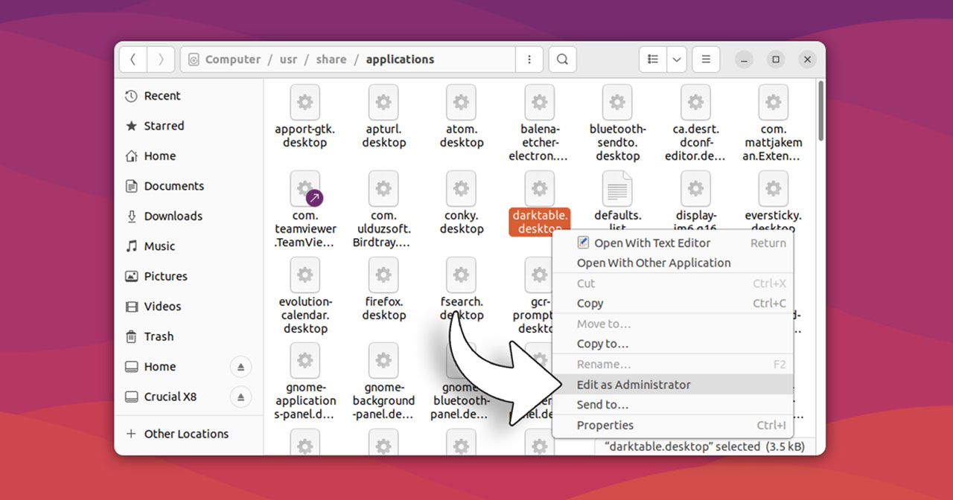

Simply go to a terminal and run:

sudo apt install nautilus-admin

Quit *Nautilus* and re-open.

Henceforth, you can right-click on pretty much any file in the file manager and select *“Edit as Administrator”*

**Step 5:**

<https://phoenixnap.com/kb/install-virtualbox-on-ubuntu>

Install VirtualBox on Ubuntu

**Prerequisites**

* A user account with **sudo** privileges
* A terminal window (Ctrl+Alt+T)

**Option 1: Install VirtualBox from Ubuntu Repositories**

The easiest way to install VirtualBox is by using the official Ubuntu repositories.

1. Open a terminal, and enter the following to update the repository:

sudo apt update

2. Download and install VirtualBox by running:

sudo apt install virtualbox

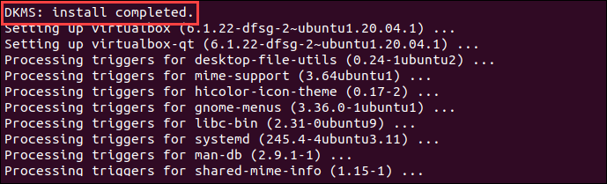

3. Next, install the VirtualBox Extension Pack:

sudo apt install virtualbox-ext-pack

Read the VirtualBox Extension Pack Personal Use and Evaluation License and select **<Ok>** to confirm you understand.

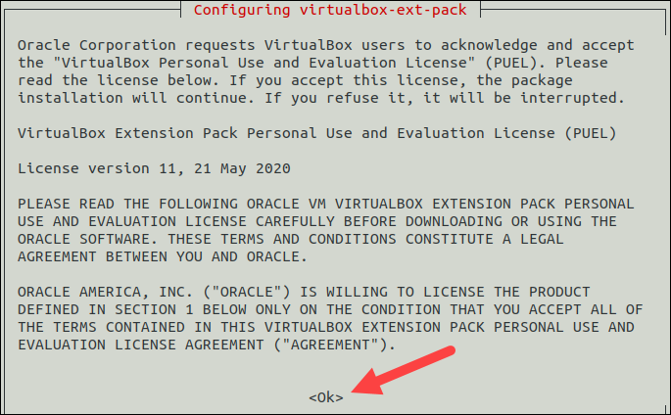

Accept the terms of the VirtualBox PUEL license by selecting **<Yes>** and hitting **Enter**.

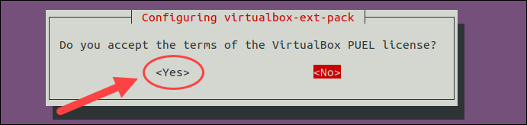

Finally, the output displays you have successfully installed "Oracle VM VirtualBox Extension Pack".

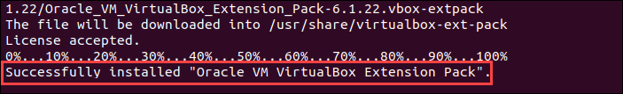

The Extension Pack enhances VirtualBox by adding USB 2.0 and 3.0 support, [remote desktop](https://phoenixnap.com/kb/how-to-enable-remote-desktop-ubuntu), and encryption.

**Step 6:**

<https://www.home-assistant.io/installation/linux>

**Install Home Assistant Operating System**

**DOWNLOAD THE APPROPRIATE IMAGE**

* [VirtualBox](https://github.com/home-assistant/operating-system/releases/download/9.4/haos_ova-9.4.vdi.zip) (.vdi)

**CREATE THE VIRTUAL MACHINE**

Load the appliance image into your virtual machine hypervisor. (Note: You are free to assign as much resources as you wish to the VM, please assign enough based on your add-on needs).

Minimum recommended assignments:

* 2 GB RAM
* 32 GB Storage
* 2vCPU

*All these can be extended if your usage calls for more resources.*

**HYPERVISOR SPECIFIC CONFIGURATION**

VirtualBox

1. Create a new virtual machine
2. Select Type “Linux” and Version “Linux 2.6 / 3.x / 4.x (64-bit)”
3. Select “Use an existing virtual hard disk file”, select the unzipped VDI file from above
4. Edit the “Settings” of the VM and go “System” then “Motherboard” and select “Enable EFI” and check for minimum settings listed above
5. Then go to “Network” “Adapter 1” choose “Bridged Adapter” and choose your Network adapter

Please keep in mind that the bridged adapter only functions over a hardwired ethernet connection. Using Wi-Fi on your VirtualBox host is unsupported.

6. Then go to "Audio" and choose "Intel HD Audio" as Audio Controller.

By default VirtualBox does not free up unused disk space. To automatically shrink the vdi disk image the discard option must be enabled:

VBoxManage storageattach <VM name> --storagectl "SATA" --port 0 --device 0 --nonrotational on --discard on

**START UP YOUR VIRTUAL MACHINE**

1. Start the Virtual Machine
2. Observe the boot process of Home Assistant Operating System
3. Once completed you will be able to reach Home Assistant on [homeassistant.local:8123](http://homeassistant.local:8123/). If you are running an older Windows version or have a stricter network configuration, you might need to access Home Assistant at [homeassistant:8123](http://homeassistant:8123/) or http://X.X.X.X:8123 (replace X.X.X.X with your ’s IP address).

With the Home Assistant Operating System installed and accessible you can continue with onboarding.

**Step 7:**

<https://www.paulligocki.com/make-virtual-box-vm-autostart/>

Make Virtual Box VM Autostart

**What you need to know**

VMNAME : Virtual Manchine Name that is registered with VirtualBox

user : Account to run as

**Edit /etc/default/virtualbox**

sudo nano /etc/default/virtualbox

**Add the following few lines into the file:**

#AutoStarting VMs

VBOXAUTOSTART_DB=/etc/vbox

VBOXAUTOSTART_CONFIG=/etc/vbox/autostart.cfg

**Create /etc/systemd/system/VMNAME.service**

sudo nano /etc/systemd/system/VMNAME.service

[Unit]

Description=vm1

After=network.target virtualbox.service

Before=runlevel2.target shutdown.target

[Service]

User=user

Group=vboxusers

Type=forking

Restart=no

TimeoutSec=5min

IgnoreSIGPIPE=no

KillMode=process

GuessMainPID=no

RemainAfterExit=yes

ExecStart=/usr/bin/VBoxManage startvm VMNAME --type headless

ExecStop=/usr/bin/VBoxManage controlvm VMNAME acpipowerbutton

[Install]

WantedBy=multi-user.target

**Reload Daemon**

sudo systemctl daemon-reload

**Test**

systemctl status VMNAME

**Start**

sudo systemctl start VMNAME

**Stop**

sudo systemctl stop VMNAME

**Enable**

sudo systemctl enable VMNAME

**Step 8:**

<https://www.linuxfordevices.com/tutorials/ubuntu/install-anydesk#:~:text=Installing%20AnyDesk%20using%20Graphical%20User%20Interface,-Other%20than%20the&text=Wait%20till%20the%20download%20completes,'Open%20with%20software%20installer'.&text=Click%20on%20the%20install%20button,it's%20installed%20on%20your%20system>.

Install Remote Desktop if needed

To install Anydesk, you need to log in as root and then execute the following commands. To [login as root](https://www.linuxfordevices.com/tutorials/linux/sudo-command-in-linux-unix), execute the following command:

|  |
| --- |
| sudo su |



Open a terminal by pressing Ctrl+Alt+T. [Update the system repositories](https://www.linuxfordevices.com/tutorials/ubuntu/restore-default-repositories) by executing the following command:

|  |
| --- |
| sudo apt update |

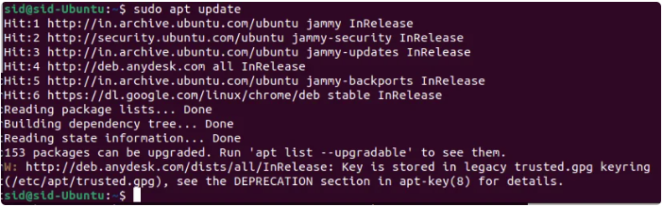

Now, Add the AnyDesk repository [GPG key](https://www.linuxfordevices.com/tutorials/linux/generate-pgp-keys-gnupg) to the trusted software providers list by executing the following command:

|  |
| --- |
| wget -qO - https://keys.anydesk.com/repos/DEB-GPG-KEY | apt-key add - |

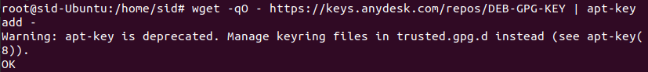

|  |
| --- |
| When the GPG key is added, add the AnyDesk repository to your system by executing the following command:  echo "deb http://deb.anydesk.com/ all main" > /etc/apt/sources.list.d/anydesk-stable.list |

anydesk-on-ubuntu-4

|  |
| --- |
| Again, update your system repositories after the addition of the AnyDesk repository. Execute the following command:  apt update |

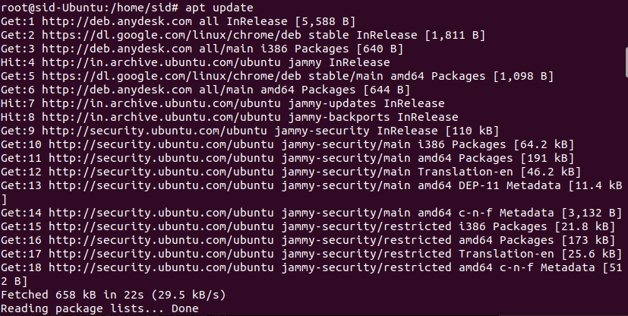

|  |
| --- |
| Install AnyDesk by executing the following command:  apt install anydesk |

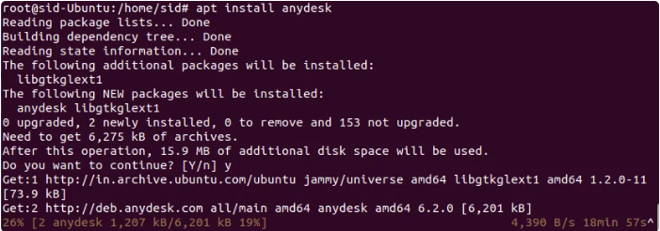

After installing Anydesk on my Ubuntu server and trying to connect from a PC, I would get a display_server_not_supported error. I was able to resolve this by going into the /etc/gdm3/custom.conf file and changing:

[daemon]

# Uncomment the line below to force the login screen to use Xorg

WaylandEnable=false

# Enabling automatic login

AutomaticLoginEnable = true

AutomaticLogin = $USERNAME

After rebooting the Ubuntu server, Anydesk now connects and shows the login screen and I can login just fine.

**Step 9:**

<https://www.ispyconnect.com/download.aspx/>

**Video Surveillance Software - Agent DVR (May not work on Ubuntu and may need to be run on a Windows VM)**

We recommend Ubuntu 20+ as it has FFmpeg v5 available as a package install. Otherwise FFmpeg will be built by the install script (Support for FFmpeg was dropped, not sure if it has been fixed)

Run in a terminal:

Command to install:

bash <(curl -s "https://raw.githubusercontent.com/ispysoftware/agent-install-scripts/main/v2/install.sh")

You may need to install curl first on Linux:

sudo apt-get install curl

**Step 10:**

<https://github.com/nicolargo/glances/wiki/Start-Glances-through-Systemd>

**Install Glances**

sudo apt install glances

**Create unit**

sudo nano /etc/systemd/system/glances.service

Insert into file to start a Glances webserver:

[Unit]

Description=Glances

After=network.target

[Service]

ExecStart=/usr/bin/glances -w

Restart=on-abort

RemainAfterExit=yes

[Install]

WantedBy=multi-user.target

**Reload Daemon**

sudo systemctl daemon-reload

**Enable unit for automatic start while booting**

sudo systemctl enable glances.service

**Start the service**

sudo systemctl start glances.service

**Step 11:**

**Resize Partition if needed (Ubuntu install usually only allocates½ of the space for use)**

The solution provided in the link Riad shared worked for me. However, I'm summing up the steps here in case the link breaks:

1. Use  **df -lh /**  to check your filesystem space and name. There you can see if there is still space, the name of the mount, etc.
2. Use  **sudo vgdisplay** to display the volume name and details. There you can see VG size (total size), Allocated (used) and Free space. The free space hints on how much you could expand your partition.
3. Use  **sudo lvextend -L +2G /dev/mapper/ubuntu--vg-ubuntu--lv** to extend the size the partition. In this example it was increased by 2Gb... edit this part according to your needs.
4. Then, use **sudo resize2fs /dev/mapper/ubuntu--vg-ubuntu--lv** to actually expand the used space.
5. Check again with  **df -lh /**  to see the changes done.

**Step 11:**

**Create another virtual machine in Vbox and install another instance of Ubuntu Server (Steps 1-4, 7 & 11) to install Node-Red and InfluxDB**